Ideation Phase

Define the Problem Statements

|  |  |
| --- | --- |
| Date | 19 September 2022 |
| Team ID | PNT2022TMID02610 |
| Project Name | Plasma Donar Application |
| Maximum Marks | 2 Marks |

Problem Statement - Plasma Donar Application

PROBLEM STATEMENT – 1

During COVID 19 crisis the requirement for plasma increased drastically as there were no vaccinations found in order to treat the infected patients. In such situation it was very difficult to find the plasma donor, check whether the donor was infected previously and was recovered, and which donor is eligible to donate plasma was a challenging task. As the plasma therapy was one of the ways to treat the infected patients getting the donor details played a major role.

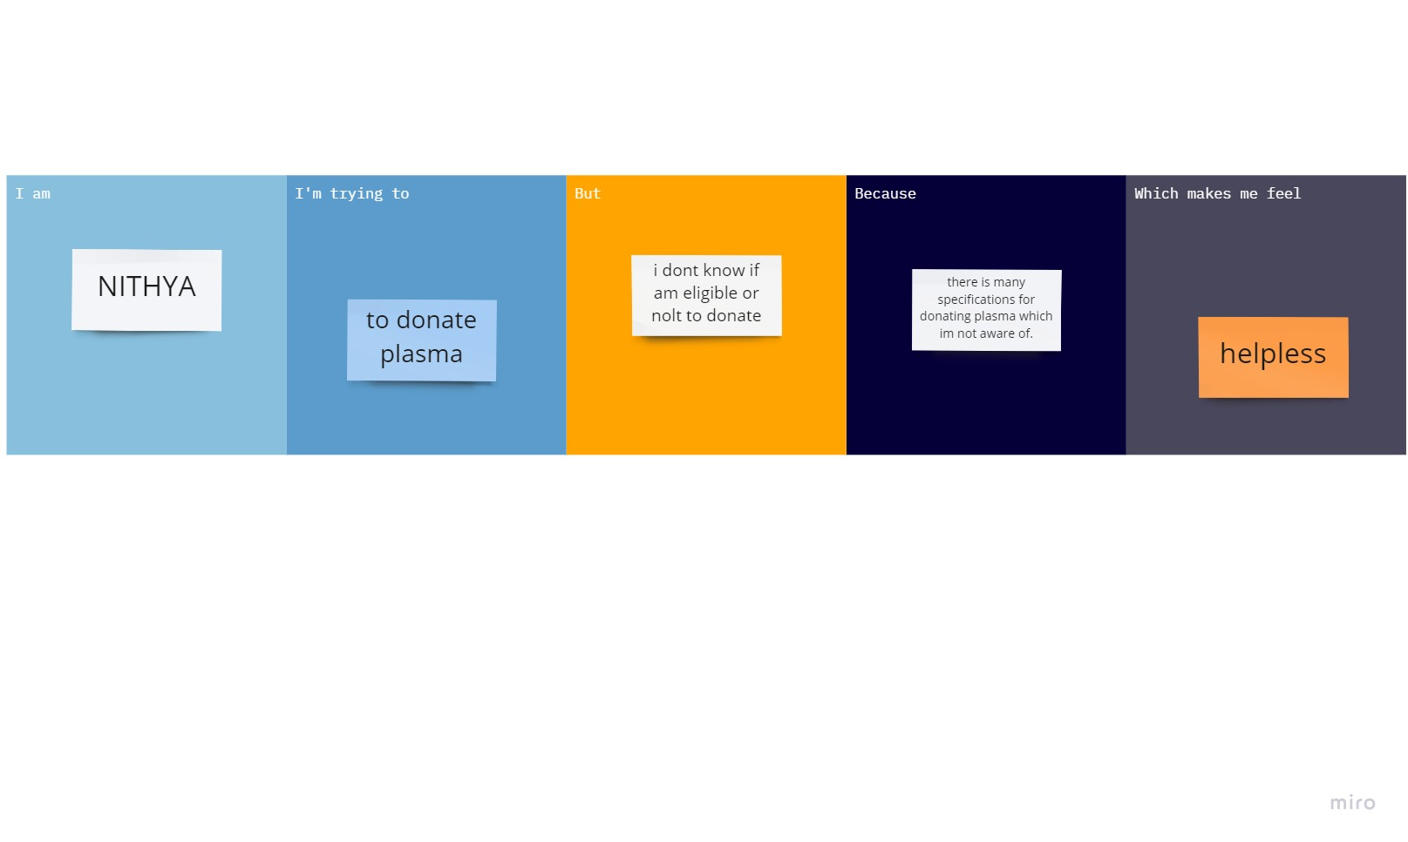

**Team ID:** PNT2022TMID02610

**Team Leader:** Nithyashree KP

**Team member:** Shaina

**Team member:** Lesha

**Team member:** Stalin